**Data Visualization – Drivers in Ireland by penalty points on 31/12/2017**

**Magda L.**

Table of Contents

Introduction 2

1. Bar Chart – Drivers received penalty points by County for 6 months period Jul – Dec 2017 2

2. Word cloud – Drivers received penalty points by County for 6 months period Jul – Dec 2017 3

3. Map 1 - Drivers received penalty points by County for 6 months period Jul – Dec 2017 4

5

4. Map 2 – 7 - Drivers received penalty points by County for each months Jul – Dec 2017 5

5. Line plot - Difference in drivers received penalty points between 6 months period July 2017 – December 2017 7

6. Packed Bubbles, Table - Dashboard - Difference in drivers received penalty points between 6 months period July 2017 – December 2017 8

8. Heat map - Percentage difference in reduction of drivers received penalty points between 6 months period July 2017 – December 2017 10

9. 3 Vertical bars - Number of drivers with given 7 and 12 Penalty points between Jul 2017 and Dec 2017 compared to total drivers received any penalty points. 11

10. Heat horizontal graph – number of drivers received 12 points by County during 6 months period Jul – Dec 2017 12

11. Car horizontal graph – number of drivers received more than 7 penalty points by County. 13

12. Scatter plot – Correlation between number of drivers receiving 12 and more than 7 Penalty points by County. 14

Conclusion 15

# Introduction

Project is made for ‘Data Visualization’ module and it’s consist 11 different visual representations of a given dataset of drivers by penalty points received in Ireland according to the stats released by the Road Safety Authority between July 2017 – December 2017. Environment: Tableau.

# Bar Chart – Drivers received penalty points by County for 6 months period Jul – Dec 2017

Firstly I would like to see how our data looks like in bar chart by County. It is total number of drivers received penalty points by county for period of 6 months from Jul 2017 – December 2017. In addition to counties I see that we also have Holders of Foreign Licence and Unknown.

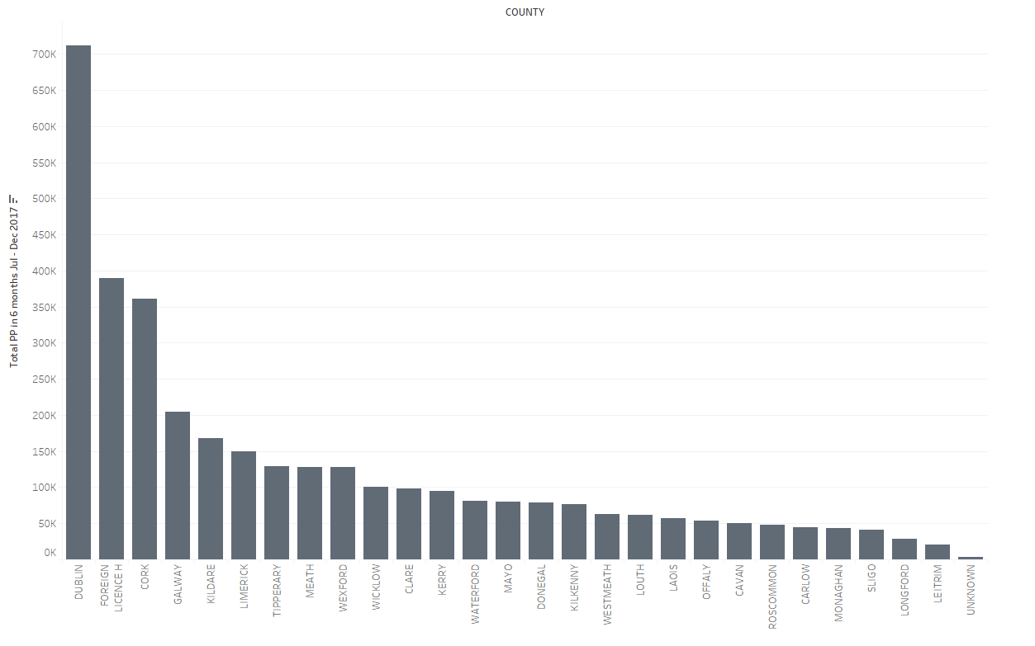

Bar chart1. Total drivers with PP for Jul – Dec 2017 by County

Bar chart is on of best diagram to show numerical data devided in categories. In our case category is a County – geographical region. It is widly used and clear to see and understand. It is one of most popular charts – classic from statistic graphs. Classic charts are good because they are common and almost everybody is able to read it.

Bar charts are used to show comparisions amoung items. In our case we compare Counties in Ireland.

We can see that most of counties had a small number of drivers with penalty points and just a 2 county had more than 350k including 1 county - Dublin with more than 700k drivers with penalty points. It also include holders of Foreigh Licence ( with more than 350k drivers with penalty points). County Longford and Letrim is county with the lowest number of drivers reciving penalty points.

It is not a surprise and data looks normal. Intresting fact is that Co. Dublin is much more different then rest of country. It would be nice to compare it with number of cars in County and see is it a correlation between also with number of garda per County. Also Co Dublin is a whole County. We could devide that for Dublin City and rest of County.

# Word cloud – Drivers received penalty points by County for 6 months period Jul – Dec 2017

Next graph – Word Cloud 1. it is actually sort kind of bubbles. It shows this same data as our bar chart but in simple words. The biggest word and more intesive blue colour then the highest number of drivers reciving penalty points in given 6 months period.

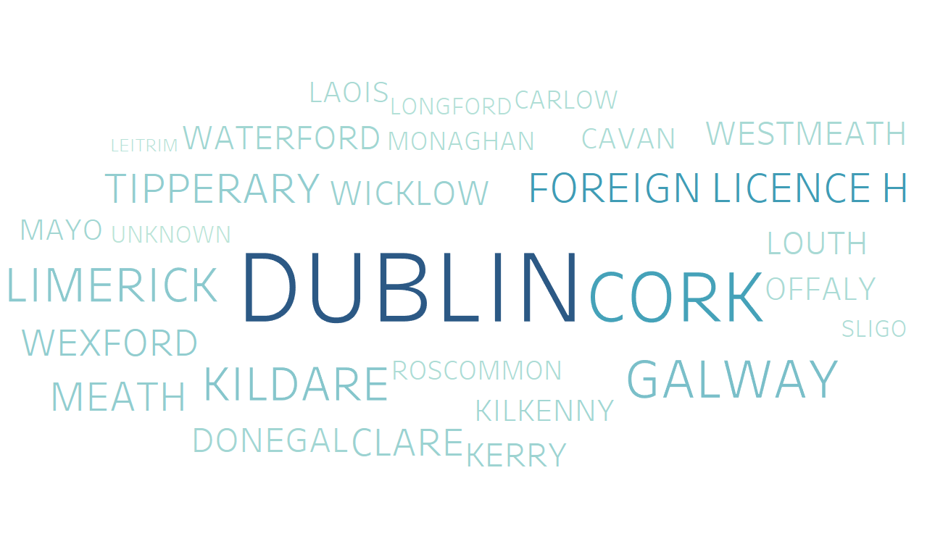

Word Cloud 1. Total penalty points Jul – Dec 2017

I like the word clouds as they in simple not complicated way show you information. It is not precisied information but enough to makes your imagination works. It is also good for all people with developed visual memory. It show comparistions between categories for only one variable. It helps to memorise data better than bar chart.

We can see that Dublin is double bigger than Cork and few times bigger than Leitrim. That already works on your imagination better than bar chart. Letrim is actually barely visible.

Lets look how looks that on map in next Chapter 3.

# Map 1 - Drivers received penalty points by County for 6 months period Jul – Dec 2017

Now lets see about what Counties we are writing about on a map.

Maps are great tool to show geographical distribution of our data. Of course we need a geo – dimension. But I think it is worth spend little more time and make sure that audience will understand data on a map than a simple table with names of counties.

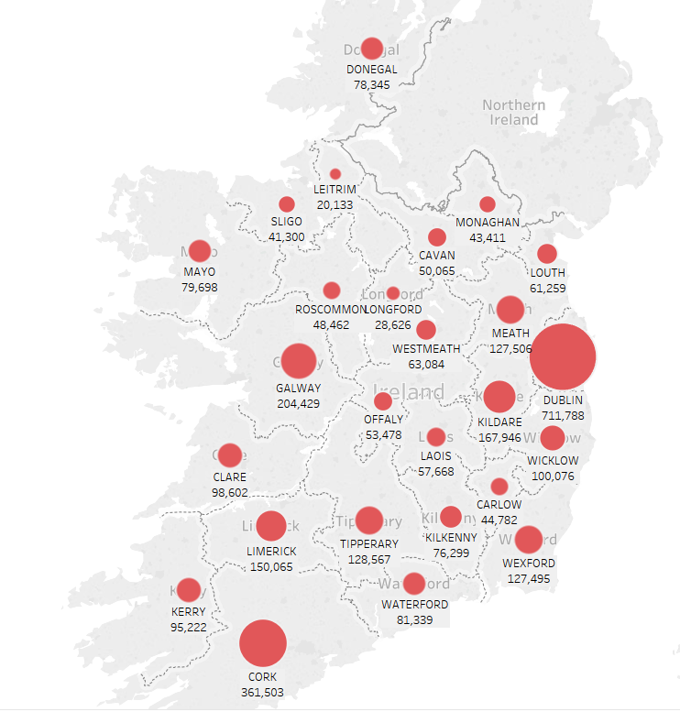

Map1. Total drivers received points by County for period Jul – Dec 2017

On this particular Map1 we can see total drivers received penalty points in our six months period. The biggest round shape than the higher number of drivers received PP. It shows comparison among counties one variable – number of drivers receiving PP. We can see that most drivers are East part of Country with big numbers in County with capitol city – Dublin and around areas – Meath, Kildare and Wicklow County. The exception to that is County Cork in the South part of Country. In the other hand North is the safest place (or with less population or with less Garda to check it and give penalty points for drivers).

It perfect situation I would compare that data with number of road accidents per county for this same period and for number of population with driving licence and proportion of drivers receiving penalty points and without penalty points.

# Map 2 – 7 - Drivers received penalty points by County for each month Jul – Dec 2017

In next maps we will see comparison of data in every single period of our datasets. That’s mean we can see is every month and look for any similarities and differences between. The map graph is this same and rules are this same as in previous example. We could do that on bar graph and would be no difference in information presented although maps looks for me better and I choose this one because it shows also geographical location. So basically gives the audience one more information than in classic bar chart.

As you can see on Map 2 to Map 7 - July, August, September, October, November and December every month was basically similar. There was no exception to that pattern.

Although we can see slightly reduction in the number of drivers receiving penalty points over time. We will have to look on that closer in different data visualisation in next chapter of that report.

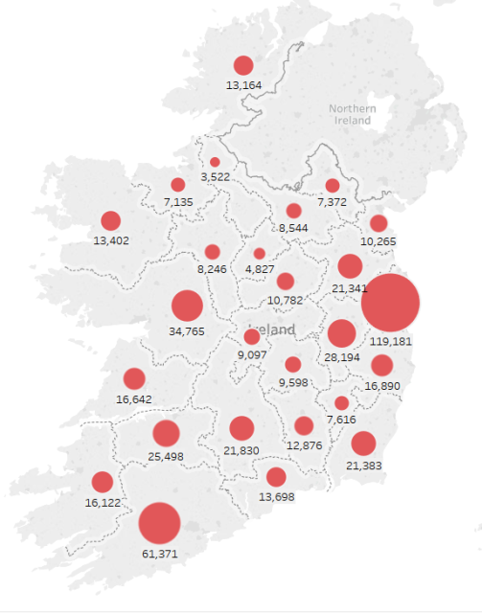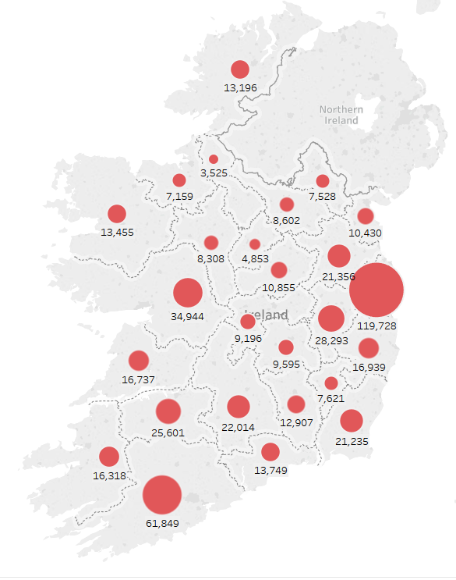

Map 2. Jul 2017 Map 3. Aug 2017

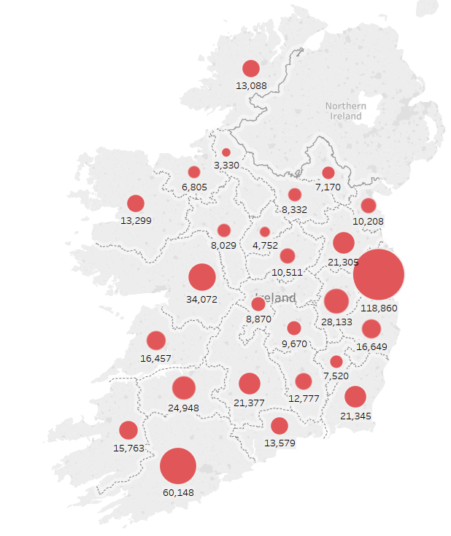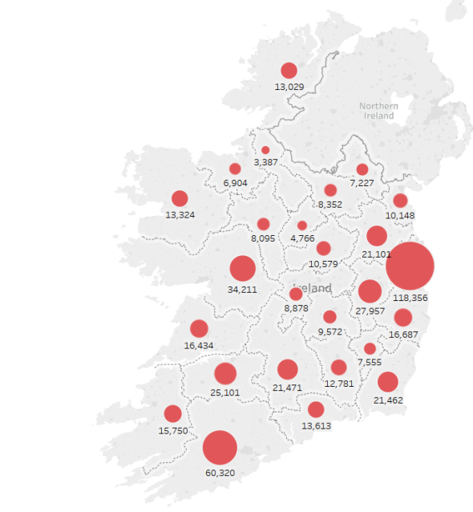

Map 4. Sep 2017 Map5. Oct 2017

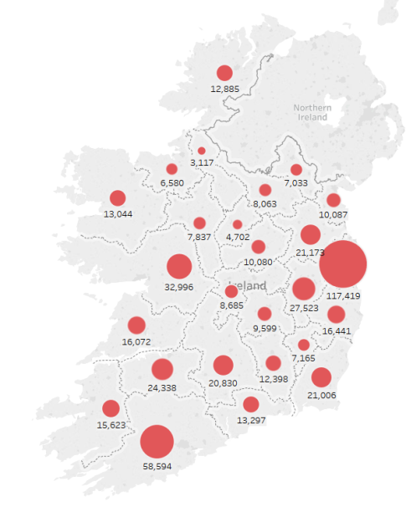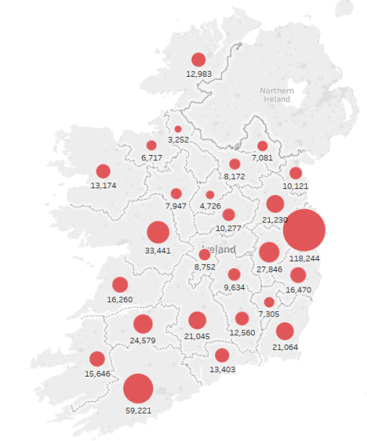

Map6. Nov 201 Map7. Dec 2017

# Line plot - Difference in drivers received penalty points between 6 months period July 2017 – December 2017

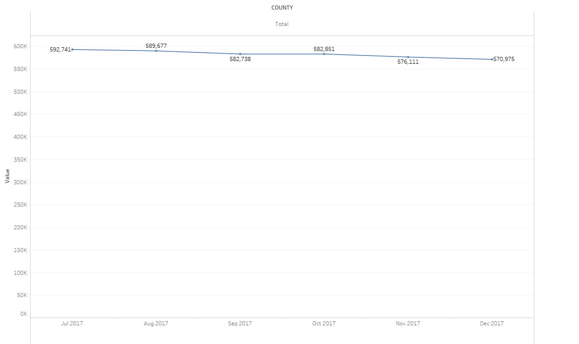

Line plot 1. Showing difference in Total from Jul 2017 – Dec 2017

Line plots are very useful. It shows comparison over time in many periods for non-cyclical data. They are perfect to show for example changes over six month period of number of drivers receiving penalty points in Ireland.

We discovered a small decrease of 21766 drivers in December when compared to July in 2017. As we can see decrease is proportionate every month.

It is interesting as its not mean that only December was different (seasonal trend). But I would compare that figure with last year and see is that July and August are quite high with number of drivers with penalty points (holiday season). Also seeing other months of year could be helpful. It is possible that Ireland open new social campaign about safe drive. We are not able to discuss or comment that trend furthermore without more data.

# Packed Bubbles, Table - Dashboard - Difference in drivers received penalty points between 6 months period July 2017 – December 2017

Used for this visualisation dashboard was created in Tableau software. It is a Packed Bubbles graph and a simple table. I choose both to make sure that the information delivered will be clear for audience. Table looks professional and it is easy to understand but the packed bubble makes you memorise the information presented. Sometimes using this same data and present of few different graphs will show you something new which you didn’t notice on beginning or will make you understand problem from different perspectives.

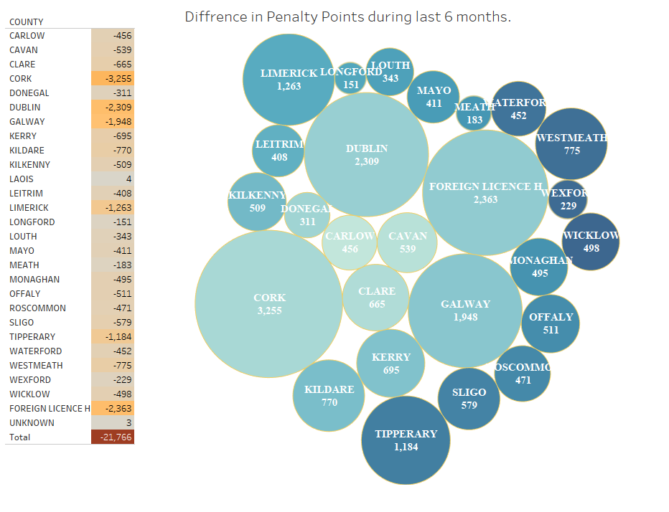

Graph1 – Difference in number of drivers receiving penalty points by County between Jul 2017 and December 2017.

On our table and bubble graph we can see actual difference in number of drivers received Penalty Points between July 2017 and December 2017. In table almost all values are negative. It’s because the difference was negative – we have reduction in number of drivers. On Bubbles in other hand we have these same values in natural numbers. Its already represent reduction in number of drivers. Few categories were not present in Bubble charts – Unknown and Co. Laois because in this Categories we can see actually increase in number of driver’s receiving pp for given period.

Interesting fact is that the biggest reduction we can observe in Cork, after we have reduction in holders of foreign licence. That numbers tell me about trends but still I don’t know where we had the biggest reduction in proportion to the number of drivers. In next chapter I will check it based on percentage reduction.

1. **Circle views – Percentage difference in reduction of drivers received penalty points between 6 months period July 2017 – December 2017**

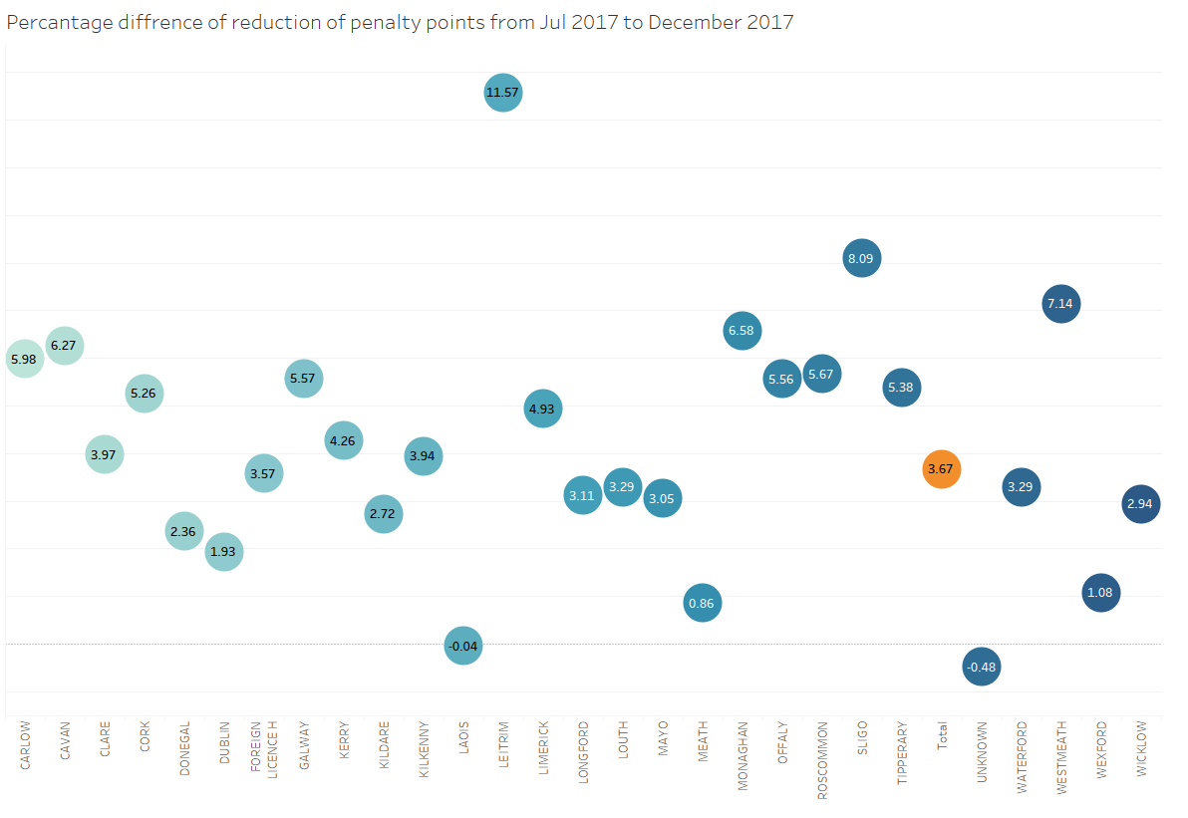

Graph2. Percentage difference in number of drivers receiving PP by County between Jul 2017 and Dec 2017.

Circle views are one of my favourite graphs. It is something between bubble and bar chart. It is clear and looks modern and professional.

Our graph shows comparisons of percentage difference between reductions in number of drivers receiving penalty points by county. The orange bubble shows total percentage difference and blue are per county. There are two minus values – in our case its mean there was no reduction but in other hand actually we have increase in number of drivers receiving pp. It is Laois and Unknown County. In other counties we can see reduction.

The biggest surprise on that graph is that the biggest percentage difference we can observe in County Leitrim with 11.57% difference second is Sligo with 8.09% difference in reduction. It could mean that over 6 month period the roads become much safer and people become more aware of importance of road regulations. But that we also need to confirm with data of Garda statistics and last year statistics (seasonal trends).

# Heat map - Percentage difference in reduction of drivers received penalty points between 6 months period July 2017 – December 2017

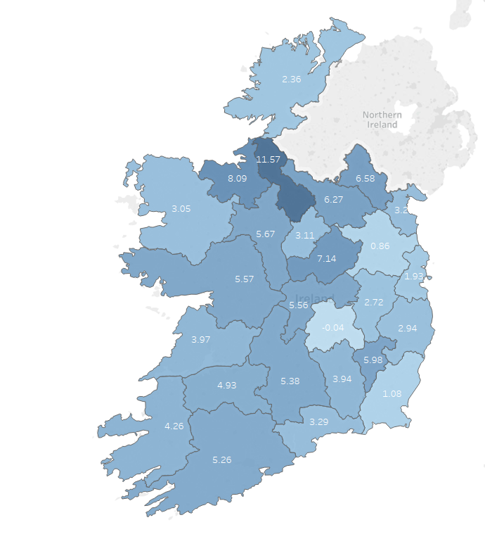

Heat map1 - Percentage difference in reduction of drivers received penalty points between 6 months period July 2017 – December 2017

Heat maps and charts are good to show visual correlation or in our case comparison of percentage difference between reductions in number of drivers receiving penalty points by county. Basically we able to see information from chapter 7 plus geographical distribution of data.

The darkest blue colour than the bigger difference in percentage reduction. The numbers only would not show us quickly the most important parts of Country.

The information which we gain looking on this particular map is that the biggest difference we can observe in the north part of Ireland. We could see in previous graph2 that the county with lowest reduction in Co. Leitrim and Co. Sligo but now we can see that they next to each other and they have borders with other counties with also big percentage reduction like: Co. Monaghan and Co. Cavan. It is very important information and it is worth for further check. If we would find no difference in population and Garda activities maybe we should look on the council activities for road safety. And in that case maybe we should adopt the best practice in rest of country.

# 3 Vertical bars - Number of drivers with given 7 and 12 Penalty points between Jul 2017 and Dec 2017 compared to total drivers received any penalty points.

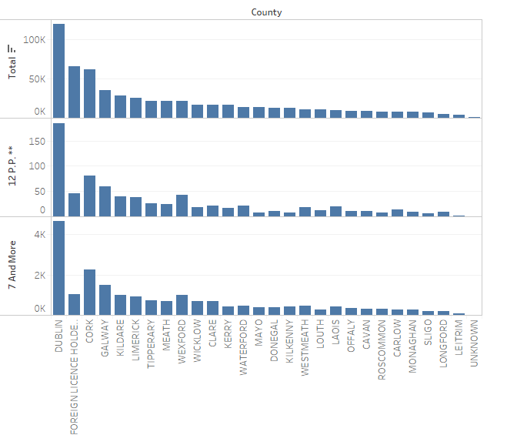

Graph3 - Number of drivers with given 7 and 12 and Any Penalty points between Jul 2017 and Dec 2017.

Set next to each other 3 bar charts all with this same categories but with different variables. Variables which you would like to compare are always good idea. Our Bars show comparison of data among Counties for few categories: all drivers received PP, drivers received 7 and more PP and drivers received 12 PP.

All are segregated based on first chart – total number of drivers. Dublin is at front in all 3 categories. But on 2 other bar charts we can see that drivers with Foreign Licence Holder are getting mostly small number of PP and in categories 7 and more and 12 PP are even not in 3rd place. That is very interesting finding. It could mean that foreign drivers just don’t know simple Irish rules and they are not ‘dangerous drivers’.

# Heat horizontal graph – number of drivers received 12 points by County during 6 months period Jul – Dec 2017

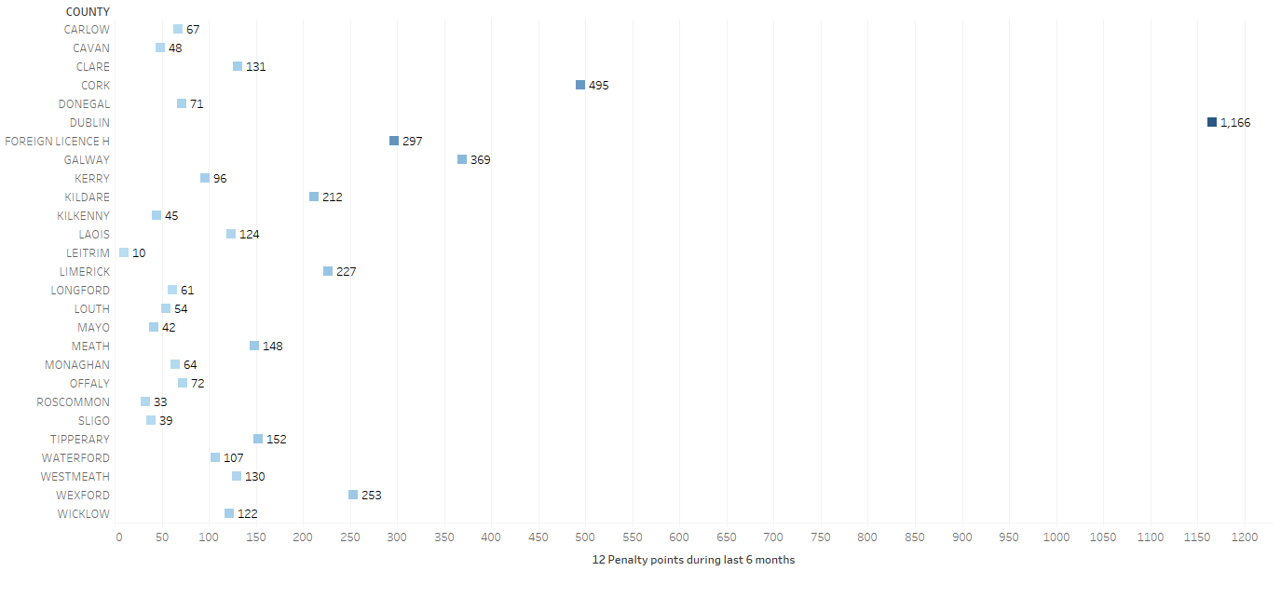

Graph4. - Number of drivers received 12 points by County during 6 months period Jul – Dec 2017

This particular graph is very interesting combination of heat map and bar graph/slot plot. The darker blue colour the biggest number of drivers receiving 12 penalty points during given period. That king of graphs looks modern and can show more information than a classic bar chart.

This graph shows comparison of one variable (number of drivers getting 12 penalty points during period Jul – Dec 2017) among counties in Ireland.

The information delivered is that Dublin is on top of number with drivers receiving 12 points – 1166 drivers for 6 month. The other Counties are far back behind with Cork having less than half of Dublin amount – 495 drivers. I wonder what cause that effect. 12 points is already disqualification for six month for all drivers. Why so many of them are disqualified in Dublin. Is capitol makes or bring that kind of drivers, is that regulations or number of all drivers? All factors should be checked.

# Car horizontal graph – number of drivers received more than 7 penalty points by County.

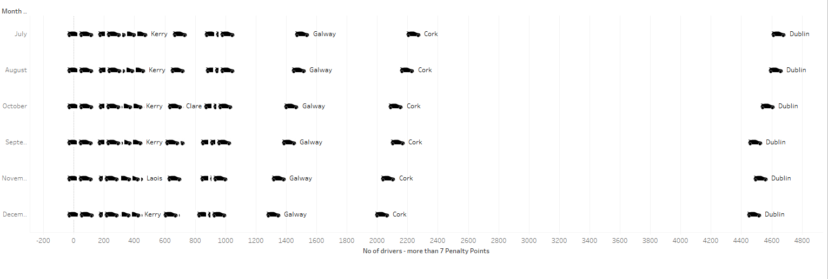

Graph5. - Number of drivers received more than 7 penalty points by County

Above graph present no of drivers received 7 and more penalty points in each month from July 2017 – December 2017. It is comparison of one variable over time for few periods for many categories (counties). It as a type of bar/scatter plot with a nice visual effect of a picture of car.

It could be presented on scatter plot as we have a comparison over time but instead I decided to mix two types to present data in more friendly visually graph.

Dublin is on top with more than 4400 drivers received 7 and more pp for each month which is not a surprise, second place have Cork which is in half way to Dublin and third is Galway. We can see here that other Counties are actually much more behind this top three.

# Scatter plot – Correlation between number of drivers receiving 12 and more than 7 Penalty points by County.

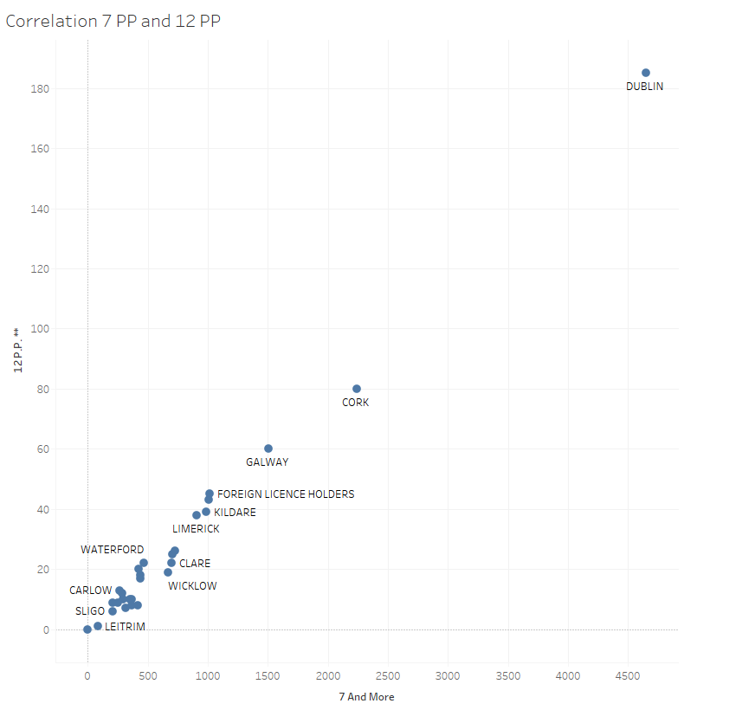

Scatter plot1 - Correlation between number of drivers receiving 12 and more than 7 Penalty points by County

On this last Data Visualisation we can see the Correlation between drivers receiving 12 penalty points and driving receiving 7 and more penalty points in Ireland.

Scatter plot was used as I wanted to show relationship between two variables. Scatter plot is a classic to show relationships. On X Axis Line we have number of drivers with 7 and more PP and on Y Axis Line we have number of drivers with 12 PP. Of course received only during this researched six month period.

We can see very strong correlation between these two variables. We can assume that in this particular case correlation do not mean causation. Both are actually the outcome of some bigger problem and we could expect that correlation. It is not something new. It would be even surprising and maybe worth to check further if we would not find any correlation or we would find see outers.

# Conclusion

Our project shows few very interesting trends and correlation. Some of them were expected but some were surprise. The most important finding is the reduction of drivers received penalty points in north part of Ireland. I would check it further. It may bring benefit to other part of country.

I learn that just looking at tables you would not realise existence of differences and patterns and you would never research further the problem. You may be even not aware of issue. Example of drivers received penalty points showed that fact drastically.